Vocabulario per allenarsi

**Fai…**

1. 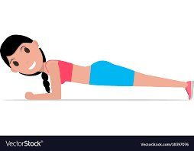i plank
2. gli addominali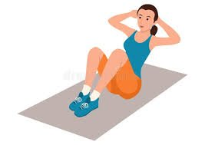

1. A black and white image of a person kicking a ball

   Description automatically generated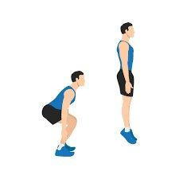 gli squat
2. 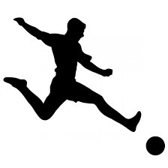Un tiro
3. 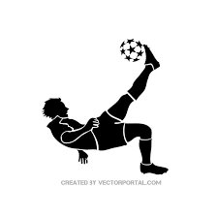i palleggi
4. A black and white image of a person kicking a ball

   Description automatically generatedUn passaggio
5. 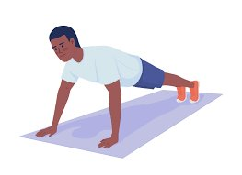le flessioni

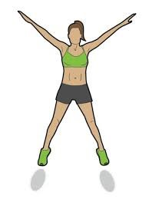

1. gli starjumps
2. i S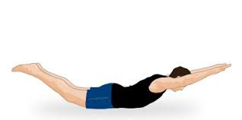uperman